PROBLEM :
In India,Bengaluru fares the worst in public transport among India’s five most populous cities. In 2017, public transport’s share of motorised trips in the city was just 41.5%, compared with 78.2% in Mumbai, which was the highest, and 77.1% in Kolkata. Bengaluru ranked below Mumbai and Chennai on a 2018 global urban mobility index. Singapore, Stockholm and Amsterdam ranked on top. The index measures the maturity, innovativeness and performance of cities’ transport systems.

Mumbai has the highest public transport use among most populous cities.

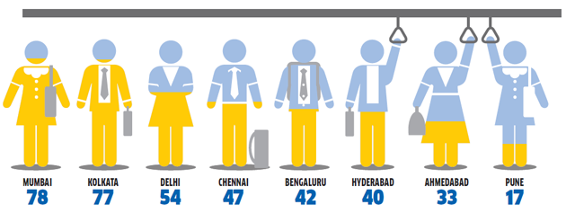

A bus roughly carries as many people as 30 cars and its fuel consumption and air pollution are one-sixth of 30 cars, according to the CSE. Cars’ share of total energy consumed by different modes of road transportation is set to double to 27% by 2040, from 13% in 2013, according to the International Energy Agency.

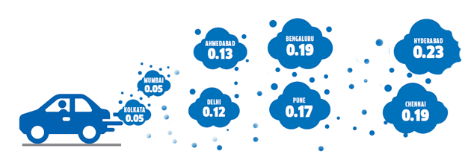
Per trip CO2 emissions (kg/day)

As we can see the power and fuel consumption is very high with cars. So more the usage of cars and private vehicles more the pollution and congestion problems will increase. As we can see the pollution is less in mumbai and kolkata as they have more number of people using transport services for travelling. As they are depending more on transport service they don’t use their private vehilcles to travel hence less pollution due to less number of cars usage, as the bus carries as many people as 30 cars so it is saving the pollution of 29 cars that may have caused pullution if they were in use instead of public transport.
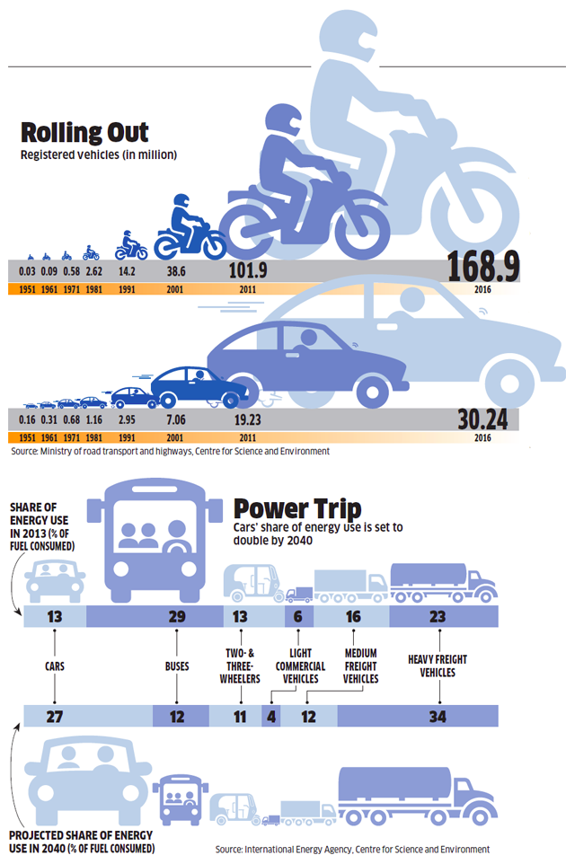

With this it is clear that personal vehicles usage is increasing year by year and also the usgae of public transport like bus is very less and will be decreasing with year passing. If we just move on with this pace definetly rush on roads, congestion problem and pollution will increase as everyone will be using their own private vehicle to travel.

All the above data and facts reveal how much is the public transport is in use. The primary reason behind this is noting but ineffiective and inefficiency of the transport services. People can’t be dependent on the service as there is no procedure followed. When going for work people have to reach on time but what if the bus has no shcedule on that time. Another case can be that people don’t have time these days so they avoid waiting on bus stops for the buses, hence they generally use their use their own vehiles for travelling purposes. Most of the people generally thinks this way and they avoid taking the buses for travelling purposes.

SOLUTION:
-> The simple and the best solution towards increasing the use of buses by more number of people is that increasing the time accuracy of the buses which will make people more relible to buses for there travelling purposes.
->The time accuracy basically means that the user will be knowing the timings of the buses coming to their nearest bus stop going to their destination
->This will help them plan their travelling according to work hours and hence without any waste of time on the bus stop waiting for bus they can come to board the bus when it is about to reach the stop.
->This will be done simply by a device on all the buses which will keep sending the data of their location
->The location will be monitered and with the help of location it can be calculated that where the bus is and how much bus stop far is htat bus from the user location.
->And acooridngly the user gets the information of the bus arrival.

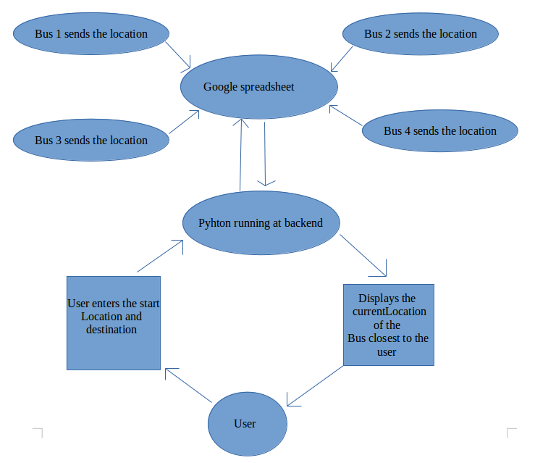

APPARATUS REQUIRED:
The module which is fitted on the buses consists of GSM module, aurduino, GPS module and DC jack (providing the power to aurdino). GSM module having a network sim which is used for providing internet services for interfacing the module with the internet.
APPROXIMATE COST:

IMPACT ON BUSINESS:
->As we see how much have the use of cabs has increased in india in recent times. This is all because of its user convinience approcah, whenever the user has a need they call the cabs. This new methodology is definetly in demand as it has eased the life of people.
->So definetly a product of similar type will be in demand and people will use it if it is making things easier and better.
->So the product just as that of cabs if implemented in buses will work the same.
-> And also the cost of travelling will be less, people won’t have to pay high amount to travel. The amount will be aproximately 1/10 of that of the cabs.
->Also if we increse the use of buses less number of private and individual cars will be prefferd and people will use transport servies as their main travelling source.
->This will further help redcing the traffic and hencefoth will reduce the pollution.

